**Client Consultation Report**

**Project: Parkinson’s Disease Prediction using AI/ML**

**Project Goal**: To develop an AI/ML-powered system that accurately predicts the eligibility of loan applicants based on personal, financial, and employment-related data. The system aims to streamline the loan approval process for financial institutions while ensuring fair, data-driven decision-making.

**Client Meetings and Questions**

This report consists of four meetings with the client, each addressing specific objectives. Below are the questions posed to the client and their responses.

**Meeting 1: P** **Understanding Parkinson’s Disease Prediction Goals Objectives:**

1. Understand the client’s vision and primary goals for the loan eligibility prediction system.
2. Discuss expected use cases and beneficiaries (loan officers, banks, financial analysts, etc.).
3. Clarify scope, dataset requirements, and model expectations.

**Geotag Photo:**

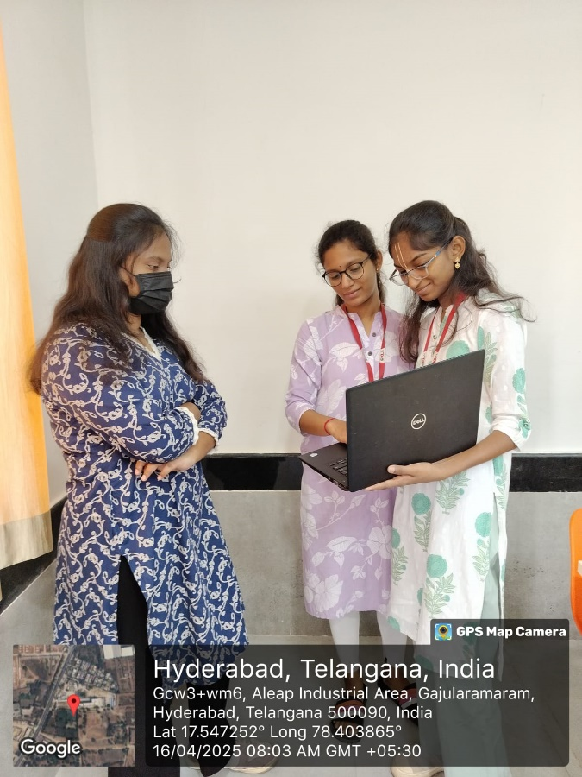

* + **Q1:** What is the core objective of the loan eligibility prediction system?

A: The goal is to automate and improve the accuracy of loan approvals by using AI/ML algorithms to predict whether an applicant is eligible for a loan, reducing manual errors and bias

* + Q2: Who are the primary users or beneficiaries of this system?

A: Loan officers, banks, financial analysts, and potentially applicants themselves, through a self-check eligibility tool..

* + Q3: What kind of data will the model use to make predictions?

A: Applicant demographic information (age, gender, marital status), financial background (income, existing loans, credit history), and employment details.

* + Q4: Are there any specific datasets the client already possesses or prefers?

A: The client suggests using publicly available datasets like those from Kaggle or the UCI Machine Learning Repository initially, followed by internal anonymized banking datasets if necessary.

* + Q5: What are your expectations regarding the performance and interpretability of the model?

A: The model should have high accuracy, be explainable (e.g., feature importance visualizations), and be able to justify rejections or approvals.

* + Q6: Would you like a web or app interface for this tool?

A: Yes, a simple and user-friendly dashboard/interface would be ideal for users to input applicant data and view predictions and explanations.

* + Q7: How soon do you expect results after a prediction request?

A: Ideally within 2–3 seconds. The system should provide real-time or near real-time eligibility prediction for a smooth user experience.

Q8: What is the scope of the MVP (Minimum Viable Product)?

A: A prediction system that accepts user input (either manual or uploaded form), processes eligibility using an ML model, and shows a clear pass/fail decision with a brief explanation of key influencing factors.

* + Q9: Will the system offer financial advice or just eligibility predictions?

A: Only eligibility predictions. It will not suggest loan amounts or financial strategies—just support for the loan approval decision.

* + Q10: What specific challenges are you hoping AI will help overcome?

A: Eliminate manual screening delays, reduce human bias, improve consistency in eligibility evaluation, and optimize workload for loan officers..

**Meeting 2: Technical Design for Parkinson’s Prediction System Objectives:**

1. Define technical and model requirements.
2. Discuss feature engineering, algorithms, and training strategies.
3. Clarify deployment and data handling needs

**Geotag Photo:**



* + Q1: What are the key technical requirements for the system?

A: The system should be lightweight, cloud-deployable, and capable of handling batch as well as real-time predictions. It should also integrate with existing banking systems via APIs.

* + Q2: What features are considered essential for predicting loan eligibility?

A: Key features include applicant income, credit history, employment type, loan amount, co-applicant income, education level, marital status, and existing liabilities..

* + Q3: What preprocessing or feature engineering steps are required?

A: Handling missing values, encoding categorical variables (like gender, education, property area), normalizing numerical features, and generating derived features like debt-to-income ratio.

* + Q4: What types of ML algorithms are preferred or should be evaluated?

A: Logistic Regression, Decision Trees, Random Forest, Gradient Boosting, and XGBoost. The client is also open to evaluating deep learning models if they significantly improve accuracy.

* + Q5: What evaluation metrics are most important?

A: Accuracy, Precision, Recall, F1-score, and AUC-ROC, especially focusing on minimizing false positives (i.e., approving risky applicants).

* + Q6: Where and how will the model be deployed?

A: Initial deployment on a cloud platform like AWS or Azure is preferred. It should be accessible via a web interface and REST APIs

* + Q7: What are the expectations for data storage and handling?

A: Data should be securely stored in encrypted databases, with role-based access control. Sensitive information must be anonymized or masked.

* + Q8: Will the system require continuous learning or periodic retraining?

A: Periodic retraining is expected, ideally every quarter, to keep the model updated with changing financial trends and applicant behavior.

* + Q9: Will the system require explainability or model interpretation features?

A: Yes. The system should include explainable AI (XAI) components such as SHAP or LIME to help users and loan officers understand why a certain prediction was made.

* + Q10: Are there any regulatory or compliance guidelines the system must follow?

A: Yes, the system must comply with data protection laws like GDPR and financial industry regulations to ensure fairness, transparency, and non-discriminatory practices in decision-making.

**Meeting 3: User Experience and Model Interaction for Parkinson’s Prediction**

* + **Objectives:**
  1. Finalize how users interact with the system
  2. Design feedback, explanation, and error handling flow.
  3. Improve accessibility for financial institution and end-user

**Geotag Photo:**



* + Q1: How should users interact with the system to input data and receive predictions?

A: Users (loan officers or applicants) will enter details via a web form or upload a CSV file. Once submitted, the system should return an eligibility decision along with a confidence score and explanation..

* + Q2: What kind of feedback or explanation should the system provide after a prediction?

A: The system must explain key factors that influenced the decision (e.g., insufficient income, high debt, short employment history) using intuitive visual indicators like graphs or scorecards.

* + Q3: How should the system handle incomplete or invalid inputs?

A: The system should flag missing or invalid fields with clear prompts and guide users to correct them. Default suggestions or validation hints should be provided in real-time.

* + Q4: What accessibility or usability features are required?

A: The interface should be user-friendly, mobile-responsive, and accessible to users with disabilities (e.g., screen reader support, keyboard navigation). Multilingual support may be added in future updates.

* + Q5: Will there be different access levels for users (e.g., admin, officer, applicant)?

A: Yes. Admins can view analytics and manage the model; loan officers can input and evaluate cases; applicants (if allowed) can perform basic self-checks without accessing backend insights.

* + Q6: Should the system support bulk predictions for multiple applicants?

A: Yes. There should be an option to upload bulk data (e.g., Excel or CSV files) and get batch predictions with downloadable results for review.

* + Q7: Will the system provide visual analytics or dashboards for model outcomes?

A: Yes. A simple dashboard should display overall prediction statistics like approval rates, risk categories, and feature importance to assist loan managers in decision-making.

* + Q8: How should errors (system failures or model issues) be communicated to users?

A: Users should receive clear, non-technical error messages along with suggested actions (e.g., “Please check your internet connection” or “Input file format not supported”).

* + Q9: Do you want the ability for users to give feedback on prediction results?

A: Yes. Loan officers should be able to flag incorrect predictions or override decisions with notes. This feedback can be stored for future model retraining.

* + Q10: What kind of user support or help features should be included?

A: The system should offer tooltips, a help section with FAQs, and optional chatbot integration for user guidance.

**Meeting 4: Deployment, Validation, and Final Checklist Objectives:**

1. Confirm final deployment plans and hosting platform.
2. Discuss testing, security, and release timeline.
3. Final QA checks and go-live readiness.

**Geotag Photo:**



* + Q1: What is the preferred deployment platform for the system?

A: The preferred platform is AWS (Amazon Web Services), using EC2 for hosting the backend and S3 for file storage. Alternatives like Azure or Heroku can be considered if necessary..

* + Q2: Will the system be hosted as a standalone app or integrated into an existing banking portal?

A: Initially, it will be deployed as a standalone web application. Later, APIs will be provided for integration into the bank’s existing systems.

* + Q3: What are the security requirements for deployment?

A: The system must use HTTPS encryption, secure authentication (e.g., OAuth 2.0 or JWT), and encrypted storage for sensitive applicant data.

* + Q4: How will the system be tested before release?

A: A combination of unit testing, integration testing, and UAT (User Acceptance Testing) will be done. Realistic sample data will be used to validate model performance.

* + Q5: What is the expected release timeline?

A: The target is to complete deployment and testing within 4–6 weeks, followed by a soft launch for internal users and a full rollout thereafter.

* + Q6: What are the final quality assurance (QA) checkpoints?

A: QA will verify model accuracy, UI responsiveness, input validation, security checks, and prediction explainability. Edge cases will also be tested thoroughly.

Q7: Who will monitor the system post-launch?

A: An assigned DevOps engineer will monitor system uptime, error logs, and API performance. Feedback from loan officers will also be collected in the first two weeks.

* + Q8: Will model validation continue post-deployment?

A: Yes. The model’s predictions will be continuously monitored against real approval outcomes to assess accuracy, and retraining will be scheduled quarterly.

* + Q9: Is there a rollback or backup plan in case of deployment issues?

A: Yes. Daily backups and version control will be in place. In case of critical issues, the system can be rolled back to the previous stable version within minutes.

* + Q10: Are there any final steps before going live?

A: Final user training, documentation handover, and system walkthrough with stakeholders will be completed. A checklist will confirm all features, security, and performance benchmarks are met.

K. Santhoshini - 2320030304

M.S. Maha Lakshmi - 2320030218

K. Abhigna - 2320030089